Pokhara University

Level: Bachelor | Semester – Fall | Year : 2005
Programme: BE |  | Full Marks: 100
Course: Engineering Mathematics I |  | Time : 3hrs.

Candidates are required to give their answers in their own words as far as practicable.
The figures in the margin indicate full marks.

Attempt all the questions.

 | - Show that the function ƒ(x) defined by  ƒ(x) = 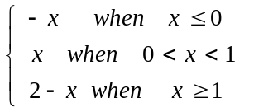  is continuous at x = 0 and x = 1, but is not differentiable at x = 1  OR  State Leibnitz's theorem for successive derivative of the product of two functions and use it to get the n^{th} derivative of the differential equation: (1 + x²) y₂ + (2x – 1) y₁ = 0  - State and prove Lagrange's Mean Value theorem and interpret it geometrically. | 8  7
 | - A square piece of tin of side 18 cm is to be made into a box without lid, cutting a square from each corner and folding up the flaps to form the box. In order to make the volume of the box maximum, what should be the sides of the square to be cut off?  OR  Define radius of curvature. Find the radius of curvature of the curve 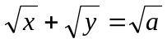 at the point where the line y = x cuts it.  - Evaluate 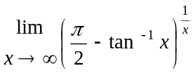 | 8  7
 | Integrate any three of the following:  i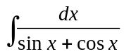 ii)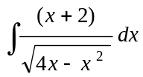  iii) 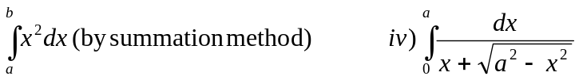 | 15
 | - Find the area of the region in the first quadrant that is bounded above by y = 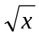 and below by the x- axis and the line y = x – 2.  OR  Find the volume of the solid generated by revolving the region between the parabola x = y² + 1 and the line x = 3 about the line x = 3.  Find the approximate area using Simpson's and Trapezoidal rule for the area bounded by the curve y = 2x² + 1, the x- axis and the lines x = 1 and x= 5 (using n = 4) and compare these results with exact value. | 7  8
 | - Define vector triple product. If a = i – 2 j – 3 k, b = 2i + j – k & c = i + 3j – 2k find (a × b) × c.  Also verify that a × (b × c) = (a . c) b – (a . b) c.  - Find the equation of the plane through (1, 2, 3) and (3, 2, 1) which is perpendicular to the plane 4x – y + 2z = 7. | 8  7
 | - Define eccentricity of a conic section, and derive the equation of a hyperbola in its standard form.  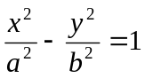  - Find the condition that the line y = mx + c may be a tangent to the ellipse 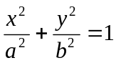 | 8  7
 | Attempt all  - Find the domain and range for 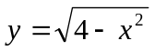  - Find all horizontal and vertical asymptotes of 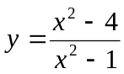  - If ƒ ' (x) > 0 in [a , b], use Lagrange's Mean Value theorem to prove ƒ(x) is an increasing function.  - Use Leibnitz's theorem to find y_{n} if y = x² e^{x}.  - Find the volume of a parallelepiped whose concurrent edges are represented by . | 10

Pokhara University

Level: Bachelor | Semester – Fall | Year : 2011
Programme: BE |  | Full Marks: 100
Course: Engineering Mathematics I |  | Pass Marks: 45
 |  | Time : 3hrs.

Candidates are required to give their answers in their own words as far as practicable.
The figures in the margin indicate full marks.

Attempt all the questions.

 | - If 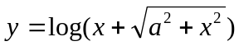 prove that .  OR  Examine the continuity and derivability at x = 0 and x =of the function f(x) defined as follows:  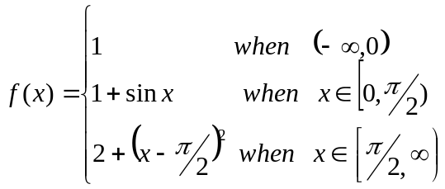  - State and prove Langrange’s Mean Value theorem. What is its geometrical meaning? | 8  8  7
 | - State L. Hospital’s theorem. Evaluate 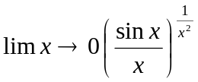  - The strength of beam varies jointly as its breadth and square of the depth. Find the dimension of the strongest beam that can be cut from a circular wooden log of radius a.  OR  Find the asymptotes of the curve x²(x - y)² - a²(x² + y²) = 0.  Integrate any three of the following | 7  8  8
 | - 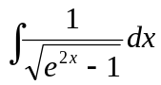  - 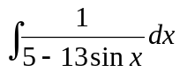  - 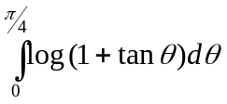  - 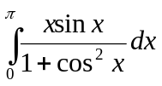 | 3×5
 | - Show that the area of astroid 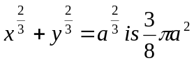.  - Obtain the volume of the solid in the first quadrant bounded above by the curve 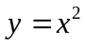, below by x-axis and on the right by the line 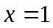 about the line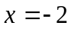.  OR  Approximate the integral 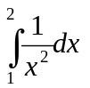with n=4, using Trapezoidal and Simpson’s rule and compare the result with exact value. | 7  8  8
 | - Find by vector method the equation of plane through the points (2, 4, 5), (1, 5, 7), and (-1, 6, 8).  - Define Vector Triple Product and show that the vectors 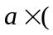×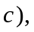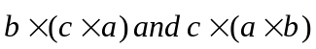 are coplanar. | 8  7
 | - Obtain the vertices, centre, coordinates of foci, eccentricity of the following ellipse: 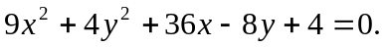  - Show that the line lx + my + n = 0 touches the hyperbola 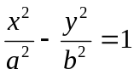 if 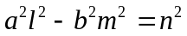. | 7  8
 | Answer the following questions:  - Find the radius of curvature at 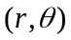 for 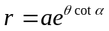  - Find the domain and range of the function y=3 + sinx  - Find the vector projection of  - What will be the arc length of the curve 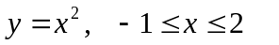  - Find equation of tangent at (2,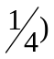on the parabola y²= 16x | 2×5

Pokhara University

Level: Bachelor | Semester – Fall | Year : 2012
Programme: BE |  | Full Marks: 100
Course: Engineering Mathematics I |  | Pass Marks: 45
 |  | Time : 3hrs.

Candidates are required to give their answers in their own words as far as practicable.
The figures in the margin indicate full marks.

Attempt all the questions.

 | - State and prove the Cauchy’s Mean Value theorem. Does the theorem applicable to the functions f(x) = x and g(x) = x² – 2x in the interval [0, 2]? Why?  - State Leibnitz's theorem for successive derivative of product of two functions y = u.v If 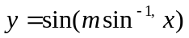show that  - 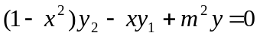  OR  Show that the function f defined as follows is continuous at x = 1 and x = 2.  f(x) = 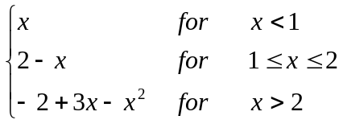  Also show that f is derivable at x = 2 but not at x = 1. | 7  8  8
 | - Evaluate 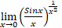  - The strength of a beam varies jointly as it’s breadth and square of the depth. Find the dimension of the strongest beam that can be cut from a circular wooden log of radius a.  OR  Find the asymptotes of the curve y³+x²y+2xy²-y+1=0. | 7  8  8
 | Integrate any THREE of the following: | 15
 | - Find the area included between the curve x² = 4y and the line x = 4y – 2.  - Find the reduction formula for and then evaluate  OR  Approximate the integral with n = 4, using Trapezoidal and Simpson’s rule. | 7  8  8
 | - Define vector triple product. If a = i – 2 j – 3 k, b = 2i + j – k & c = i + 3j – 2k find (a × b) × c. Also verify that a × (b × c) = (a . c)b – (a . b) c.  - Find a set of reciprocal vector of | 7  8
 | - Define eccentricity of a conic section, and derive the equation of a hyperbola in its standard form.  - Find the condition for the line to be tangent to the ellipse 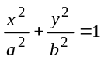. | 8  7
 | Attempt all the questions:  - Evaluate  - Find the radius of curvature of curve 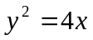at (0, 0).  - Integrate 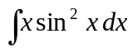  - Find the center, vertices and foci of the ellipse  - Evaluate 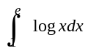 | 2  2  2  2  2

Pokhara University

Level: Bachelor | Semester: Spring | Year : 2012
Programme: BE |  | Full Marks: 100
Course: Engineering Mathematics I |  | Pass Marks: 45
 |  | Time : 3hrs.

Candidates are required to give their answers in their own words as far as practicable.
The figures in the margin indicate full marks.

Attempt all the questions.

 | - Show that the function  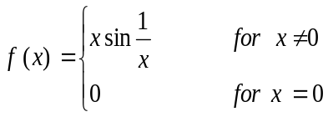  Is continuous at x=0 but not differentiable at x=0.  OR  State Leibnitz theorem. If 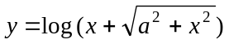, show that 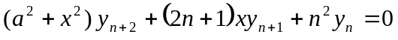  - State and prove Cauchy’s mean value theorem. | 8  7
 | - Show that : 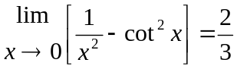  OR  Find the total surface area of the right circular cylinder of greatest surface that can be inscribed in a given sphere of radious r.  - When does a straight line called an asymptote of a given curve. Find the asymptote of x³ + y³ = 3axy. | 7  8
 | - Evaluate 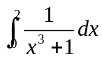 using Simpson's and Trapezoidal rule with n = 4 and compare it with the exact value.  OR  Find the reduction formula for 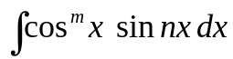and then evaluate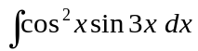  - Show that the volume of the solid generated by revolving the asteroid about x- axis is  Find the Volume of the Sphere. | 7  8
 | - Integrate ( Any three) | 15
 | - Using vector method find the equation of a plane through the point (2,1,-1) and perpendicular to both the planes  2x + y – z = 3, x + 2y + z = 2.  - Define scalar triple product. Give its geometrical interpretation. If the vectors , 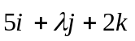and are coplanar, Find the value of . | 7  8
 | - Define eccentricity of a conic section and classify the conic sections with respect to eccentricity. Also find the equation of hyperbola in its standard form.  - Find the equations of tangents to the ellipse x³ + 3y² =3 which are parallel to the line 4x-y +8 =0. | 8  7
 | Write short notes on:  - Find the asymptotes to the curve .  - Integrate  - Find the center and vertices of the hyperbola 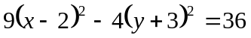  - Evaluate the improper integral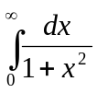  - Find the equation of hyperbola whose focus is (2,1), directrix is x + 2y = 1 and eccentricity (e) = . | 2  2  2  2  2

Pokhara University

Level: Bachelor | Semester: Fall | Year : 2013
Programme: BE |  | Full Marks: 100
Course: Engineering Mathematics I |  | Pass Marks: 45
 |  | Time : 3hrs.

Candidates are required to give their answers in their own words as far as practicable.
The figures in the margin indicate full marks.

Attempt all the questions.

 | - Define continuity and differentiability of a function. Show that the function defined by  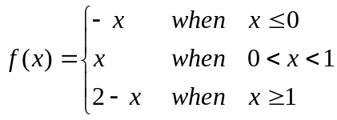  Is continuous at x=0 and x=1, but is not derivable at x=1.  OR  State Leibnitz and prove theorem. If y=, show that  - State and prove Lagrange’s Mean Value theorem. If f’( x ) is positive in 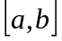show that f( x ) is increasing in | 8  7
 | Show that 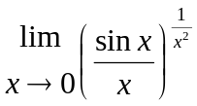=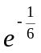  OR  Find the total surface area of the right circular cylinder of greatest surface that can be inscribed in a given sphere of radius r.  - Find all the asymptotes of y³+x²y+2xy²-y +1 =0 | 8  7
 | Integrate the followings:(Any three)  - 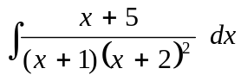  - 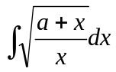  - 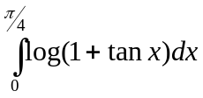  - 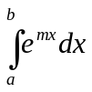(by summation method) | 15
 | - Find the area of the region of the circle x²+y²=4 cut off by the line x-2y=-2 in the first two quadrants.  OR  Find the volume of the solid in the region bounded by the curves x=y², x=0, y=-1, y=1 revolved about y-axis.  - Evaluate using Simson’s and Trapezoidal rule with n=4 and compare it with the exact value. | 7  8
 | - Obtain the vertices, coordinates of foci, directrix, and eccentricity of the following hyperbola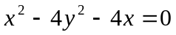  - Find the equation of tangent to the ellipse 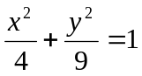, which is parallel to the line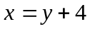 | 8  7
 | - Using vector method obtain the equation of plane passing through the Point (4,1,3) and perpendicular to the line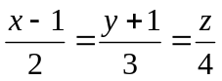  - If 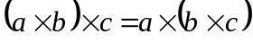 Prove that 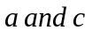 are collinear. | 8  7
 | Attempt all questions:  - Find the radius of curvature of y = x²+4 at (0, 4)  - Integrate: if exists.  - Show that =  - Find the volume of a parallelepiped whose concurrent edges are represented by . | 4×2.5

Pokhara University

Level: Bachelor | Semester: Spring | Year : 2013
Programme: Architecture |  | Full Marks: 100
Course: Mathematics I |  | Pass Marks: 45
 |  | Time : 3hrs.

Candidates are required to give their answers in their own words as far as practicable.
The figures in the margin indicate full marks.

Attempt all the questions.

 | - Examine the continuity and differentiability of f (x) at x =0, where f (x) is defined as  f(x) = x sin for x ≠ 0  = 0 for x = 0  - Find of the given functions:  - y = 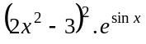  - 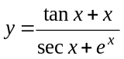  - x⁴y³ = (x +y)⁷  - 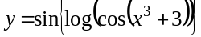 | 7  8
 | Integrate any three of:  - 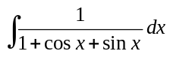  - 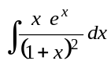  - 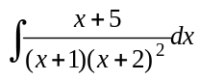  - 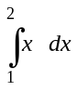 (by summation method) | 3×5
 | - Show that.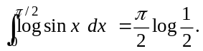  - Approximate 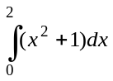 by Trapezoidal and Simpson’s rule with n = 4 and compare the result with exact value. | 7  8
 | - Evaluate.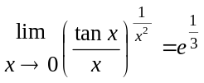  OR  Find all the asymptotes of y³+x²y+2xy²-y +1 = 0.  - Show the semi vertical angle of the cone of the maximum volume and given slant height is tan⁻¹  OR  State Euler’s theorem for homogeneous function for two variables in x and y. If u = sin ⁻¹ 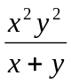 then show that 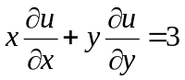tan u. | 7  8
 | - Define a conic section. Find the equation of the hyperbola in it’s in its standard form.  - Find the equation the tangent at (x_{1,}y₁) of the ellipse 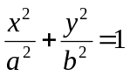 | 8  7
 | - Find the area bounded by y = x² and the line y² =x  - The area bounded by y = x²⁻ and. the line y = x is revolved about y axis. Find the volume of the solid thus generated. | 7  8
 | Attempt all :  - Find the vertex, equation of directrix and line of symmetry of the parabola (y + 1)² = 4(x - 2)  - Evaluate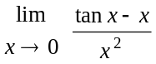.  - If  =x⁴ + x²y² then verify that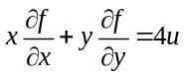  - Find the center and radius of the circle x² +y² + 8x + 2y - 8= 0  - Evaluate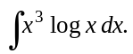. | 5×2

Pokhara University

Level: Bachelor | Semester: Fall | Year : 2014
Programme: BE |  | Full Marks: 100
Course: Engineering Mathematics I |  | Pass Marks: 45
 |  | Time : 3hrs.

Candidates are required to give their answers in their own words as far as practicable.
The figures in the margin indicate full marks.

Attempt all the questions.

 | - Define continuity and differentiability of a function. Show that differentiability of a function f(x)=a, implies continuity but converse may not be always true.  OR  If show that  - State and prove Rolle’s theorem. Is Rolle's theorem applicable to the function in the interval? | 7  8
 | - Define indeterminate forms. State L Hopital rule and using it, show that 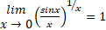.  - Find the altitude of the right circular cylinder of maximum volume that can be inscribed in a given right circular cone of height h.  OR  Define the asymptotes of a curve and classify them. Find the asympotes of the curve : | 8  7
 | Integrate Any Three  - 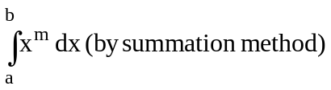  - 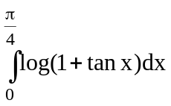 | 3×5
 | - Find the area bounded by and .  OR  Find the volume of the solid in the region in first quadrant bounded by the parabola , the y – axis and the line y=1 revolving about the line x = 3/2.  - Use Trapezoidal and Simpson's rule with n = 6 to approximate the area between the curve 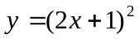ordinates x = 1, x = 4 and x axis. Compare the result with exact value. | 7  8
 | - Define vector triple product. If , and find . Also verify that  - Find the equation of the plane through the point (2,4,5) and perpendicular to the line x=5+t, y=1+3t, z=4t. | 8  7
 | - Define eccentricity of a conic section, and derive the equation of a hyperbola in its standard form.  - Find the condition that the line lx+my n=0 touches the parabola y²=4ax. Find the point of contact. | 8  7
 | Answer the followings:  - Find the radius of curvature of the curve at (x,y).  - Integrate 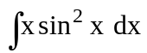  - Evaluate improper integral 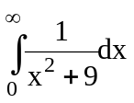  - If 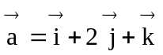, 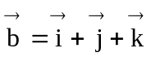, find unit vector along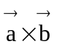. | 4×2.5

